LAB: Signature Analysis and Metadata

Summary
This lab is comprised of two mini labs using Metadata and Signature Analysis to find various files. In these labs you will gain hands on experience with the following items:
- System and Application Metadata
- Bookmarking and Reporting with EnCase
- Finding files using File Signatures and File Name Extensions
- Set Include, Blue Check and Gallery View in EnCase
- Removing Application Metadata from Microsoft Office Documents

Learning Outcomes
Do not simply follow the lab instructions – try to think about what you are doing and why. Follow up the additional reading and references where given. Think carefully about the answers to any additional questions given. Try to find the time to take on any additional challenges or optional extension work given.
After completing this LAB, you should be able to:
- Describe and Analyse System and Application Metadata and explain its usefulness in Digital Forensics
- Describe and Perform a Signature Analysis and use the results to find evidence

Preparation: Load the Virtual Disk for analysis
Copy and start the EnCase Clone VM
Copy the Laquita.vmdk file from "Q:\ACESStudent\VMStore\COMMON\55-7632-00NL_ComputerForensicsInvestigationandRespose\Semester 2 2023-24\Lab 2 File Signatures and Metadata" to the same folder on the D: drive into which you copied your EnCase Clone VM
Using VM > Settings > Add > Hard Disk > Add Existing Hard Disk, add the Laquita.vmdk disk to your examination machine. Make sure that you "Keep Existing Format", otherwise you may overwrite evidence!
Create a new Case.
- Give it a relevant name. The lab is on Metadata and Signatures. You could call your case “Metadata and Signatures”, for example.
- Change the Base Folder to the D:\ drive (why?)
- Complete the Case Number, Date, Examiner Name, ID, Agency and Description with some sensible choices.
- It is OK to back up to the C:\ drive, or to turn backups off, but in real life you would probably want a fresh, cleaned backup disk.
- Add the Laquita.vmdk disk as a local disk to your evidence. Remember that FastBlockSE does not write block the vmdk file.
- Create a folder called EvidenceCache on the D:\ drive inside your Case folder.
- Acquire the evidence, giving sensible options for the fields which must be completed. Browse to the EvidenceCache folder you just created for the evidence acquisition file. This is so that you can copy the whole case, including evidence, from the D:\ drive if you need to save it. The acquisition should take less than 1 minute.
- Process the evidence. Make sure you ONLY process the signature analysis. Change the Options Label to "Signature Only". Your Processor Options window should look like this:

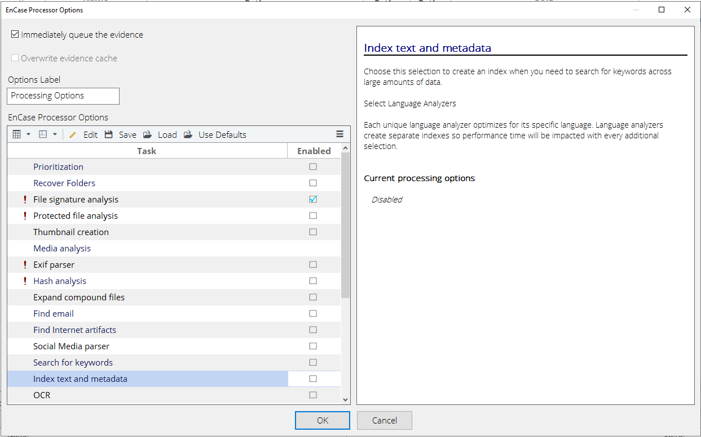

Task 1 Metadata

Task 1a: Metadata Case study:
For this task, discuss the case study in pairs. Examine the evidence individually, and discuss your findings in pairs.
Leonard Kufner is an office worker for Dewitt & Company. He has enjoyed the attention of his boss, Laquita Hishaw, but when Laquita starts going out with the company executive Peter Gutierres, he gets angry and jealous, and decides to harm Laquita’s career by accusing her of sexual harassment.
Leonard creates a document which looks like a letter from Laquita suggesting an intimate encounter with Leonard, and threatening his job if he does not comply. Leonard prints a copy of the letter. On Tuesday 8 August 2017, while Laquita is away on business, he copies the document to her computer.
When Laquita returns on 9 August, Leonard shows the printed document to Peter Gutierres claiming that it had been slipped under the door for him to find. He asks for disciplinary action to be taken against Laquita.
Peter Gutierres decides to examine Laquita’s computer to verify the accusation.
You are given the disk from Laquita’s computer. You are also given the information that Laquita has a copy of Microsoft Office Word 2016 installed on her computer. To save disk space and analysis, Word 2016 is not actually installed, but the information is still relevant. You are asked to find evidence to confirm or deny Leonard’s claim that Laquita wrote the document, printed it, and slipped it under Leonard’s door

You need to do the following:
- Find whether the relevant document exists on Laquita’s computer
- Examine and report on the system metadata of the document
- Examine and report on the application metadata of the document
- Give an opinion on the actual course of events.

Examining System and Application Metadata
First find the file. If you scan through the obvious location which is C:\Users\Laquita\Documents\ you will easily find it. We will later look at other ways of finding documents or files using signatures, hashes and keyword searches.

System Metadata
The system metadata for the document is stored in the file system, and is not part of the file data. System metadata includes the date and time Created, Modified and Last Accessed. Other items such as the file size, file owner and access permissions are also considered system metadata.
Examine the Modified/Accessed/Created (MAC) times by selecting the file, and clicking on the Report tab.
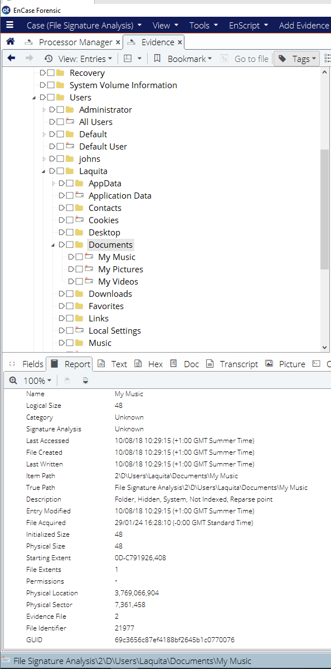
Look at the Last Accessed, File Created and Last Written dates and time.
Note that by default on many operating systems including Windows 7 and 10, the “Last Accessed” date is not updated by the file system, because this would cause a write to the system metadata every time a file is read. There is a registry setting which controls this behaviour, but it is normally left not updating the metadata for performance reasons. This means that in most cases, “Last Accessed” dates are not clear evidence of when a file was last accessed.
The File Created Time is the time the file was created on the file system. When a file is copied from one device to another, for example from a USB memory stick to the hard drive, then the File Created time will be set to the date and time the file was copied to the new system.
The Last Written Time is the time the contents of the file or the metadata was last modified by the file system
When a file is copied from one device to another, the Last Written Time is left unchanged, and the File Created Time is set to the time the file was copied to the new device. This can lead to metadata showing that a file was created after it was modified!
What do these dates and times suggest about what actually happened?
File Ownership and permissions can also be said to be system metadata. A file will normally be owned by the user account which was used to create the file. Check the owner of the file by viewing the permissions, which are also shown in the Report tab:
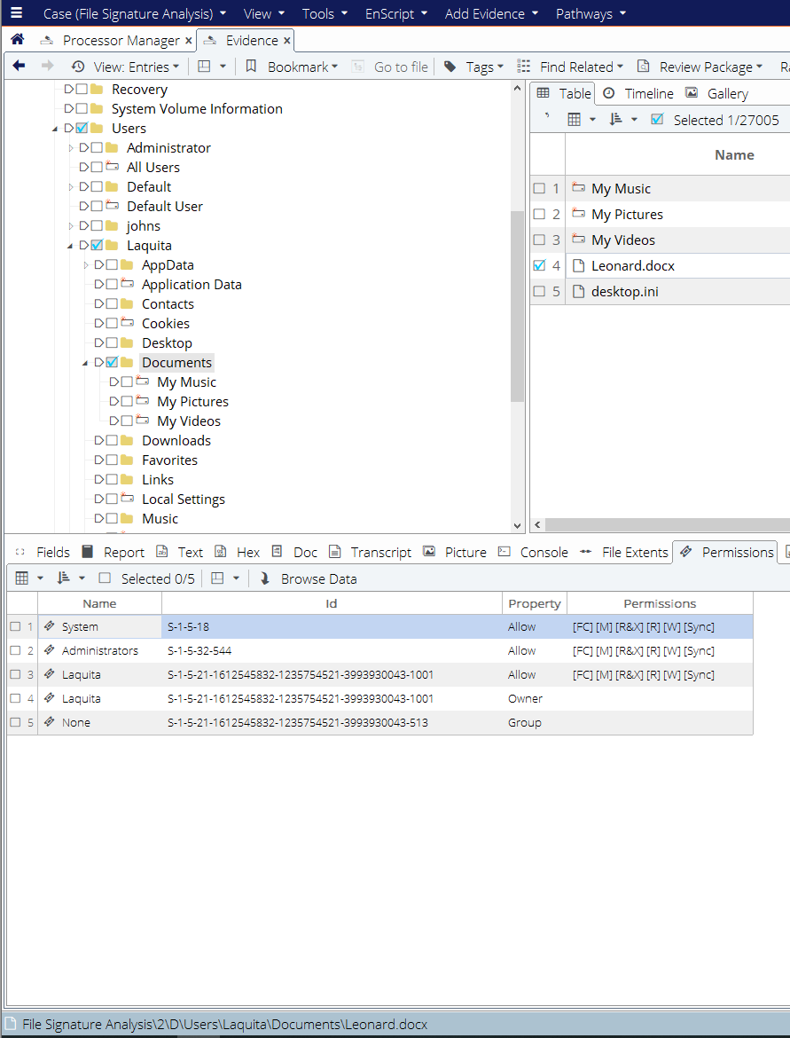
Note that Laquita is the Owner, and has Allow permissions.
What does this suggest about how the file was created? Does this confirm or deny the accusation by Leonard?

Application Metadata
Application metadata is generally stored by the application which creates or modifies the file, and is stored with the contents of the file. Different applications will store different metadata. Application metadata may not be stored in a readable format, and is often easier to decode using the application itself. EnCase is not good at showing Word Document metadata.
For this reason, it is easiest to export the document to the file system, and examine the application metadata with the application itself.
Export the files by blue checking it, right clicking, selecting "Entries", "Copy Files", and copying "All Selected Files" to "Separate Files".
Copy the Logical file (we will later look at the difference between the Logical and Physical File contents). Save the file in the default location on the D:\ drive.
Note that when you copy the file EnCase maintains the System Metadata MAC times even though the copy has just been created. The Application Metadata will also be unchanged.
Examine the exported file in Windows Explorer. Right click on the file, select "properties" and "details".
Note that the Application Metadata for Microsoft Word also shows Content Created and Date Last Saved, but includes a number of additional fields such as Author, Revision, Company, Last Printed, Editing time and more. These fields are populated by the application itself, and may be highly relevant in a forensic examination.
What does the Application Metadata show about the Author of the document, and when it was printed? Does this confirm or deny the accusation by Leonard?

More detailed Application Metadata
Microsoft Word also stores the Version which was last used to modify the document. This is more difficult to determine, as it is saved in XML and compressed in the document.
- Make a copy of the *.docx file and change the extension to *.zip
- Open the zip file
- Extract the docProps\app.xml file, and open this file with a text editor
- Look at the end for the "AppVersion" tag value

Appversion Tag Value | Microsoft Word Version
12.0000 | Word 2007
14.0000 | Word 2010
15.0000 | Word 2013
16.0000 | Word 2016

What evidence does the version number show about the document found on Laquita’s computer? Does this support or deny Leonard’s accusation?

Task 2b: EnCase Bookmarks and Reports
EnCase allows the examiner to “Bookmark” interesting evidence. You can add various items such as Images, Keywords, registry entries or Hex Values to your set of bookmarks, and you can add your own comments to the bookmarks such as “The Last Modified date shows that…”
You can Bookmark the relevant files by right clicking on them and choosing Bookmark, Single Item, and adding a comment and choosing a Destination Folder (this will appear in the report).
When you have bookmarked all your evidence, you can get EnCase to generate a report in various formats including HTML and pdf. You can also cut and paste from the report to your own document. Your choice of the type of Case which you created in EnCase (such as UK Standard or UK Forensic) will determine what information is available in the Report title page and headers.

Create Bookmarks and a Report
Bookmark all the relevant evidence you have found, and produce a report showing the evidence and giving details of your conclusions for the Case Study above. Notice how encase automatically adds the key metadata and your comments to the report, as well as a thumbnail of images. Notice also how the Case Details you entered earlier are used.

Task 2c: System and Application Metadata
Create a new word document by creating a copy of the document above. Check what happens to the System and Application Metadata – Compare the dates, including the "origin" dates used by Microsoft Office (Application Metadata) and the "file" dates maintained by Windows (System Metadata).
Now try editing the copy with Word. Check which metadata changes, and which stays the same?

Task 2: Signature analysis

Task 2: Check the Signature values
In the loaded evidence check that the file signatures have been verified. Do this by viewing the files in the Table Pane and scrolling to the appropriate column. If you select the drop down menu on the Table Pane, you can lock the column so that the file name remains in place while you scroll:
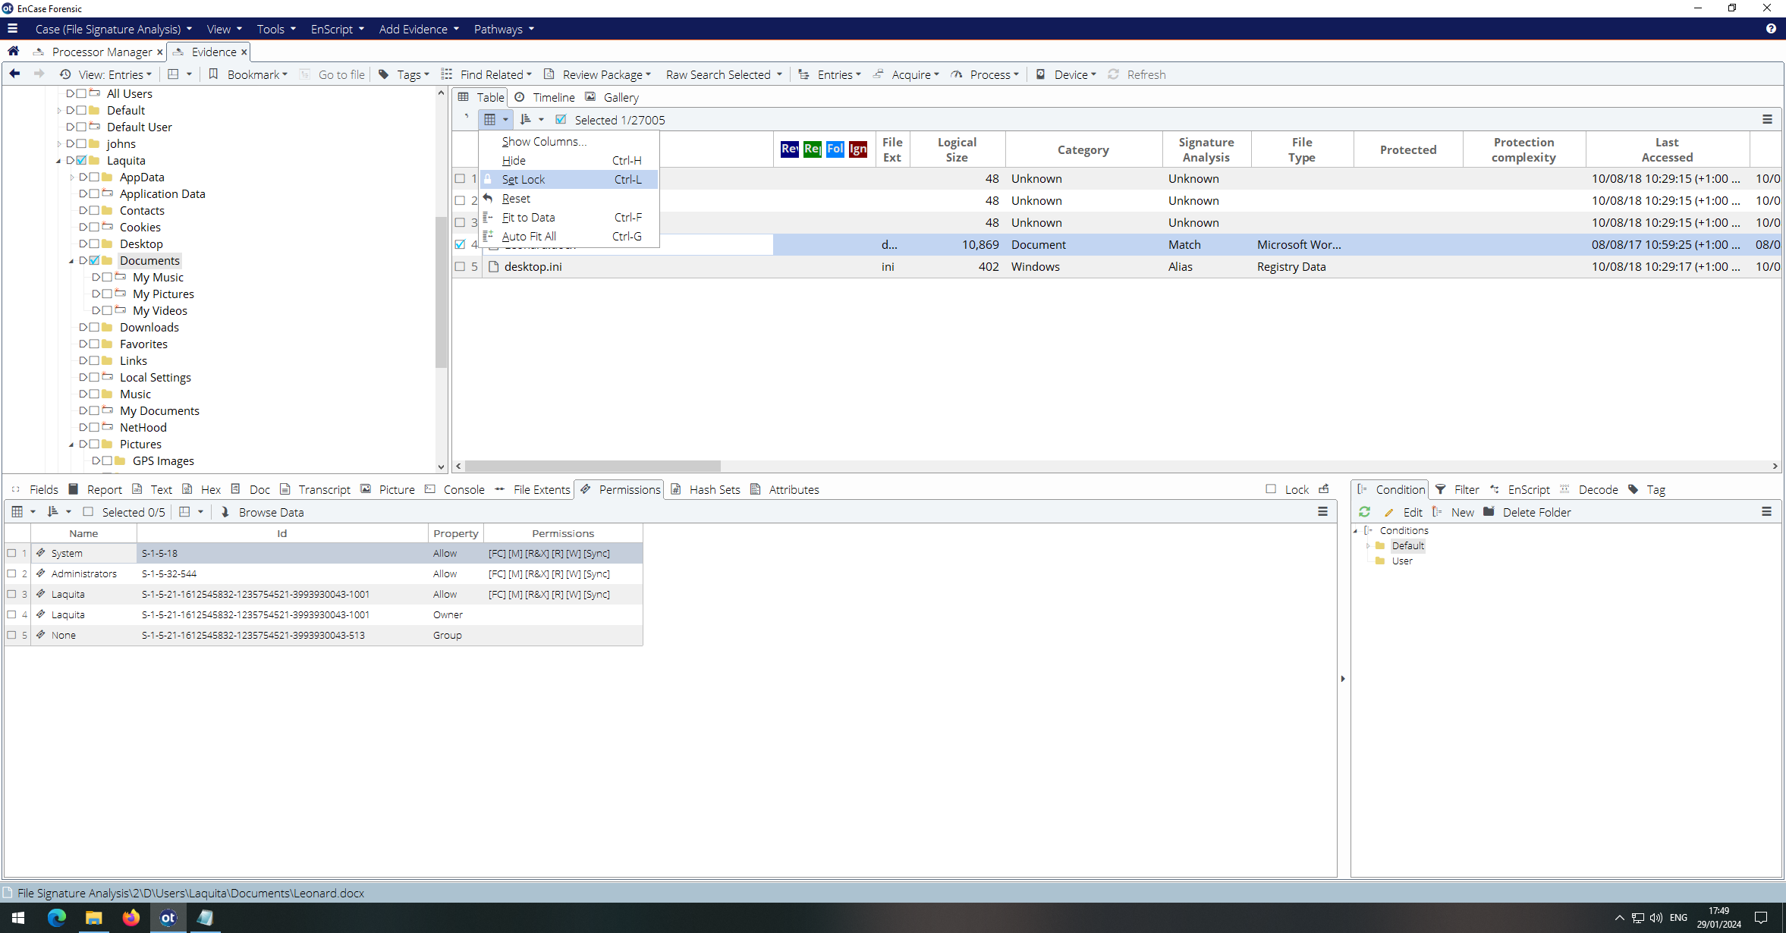
Scroll right and check that the signatures have been verified. Notice that files are described as Alias, Match or Unknown. The file type is taken from the File Signature, and the Alias or Match is then determined by the file extension. 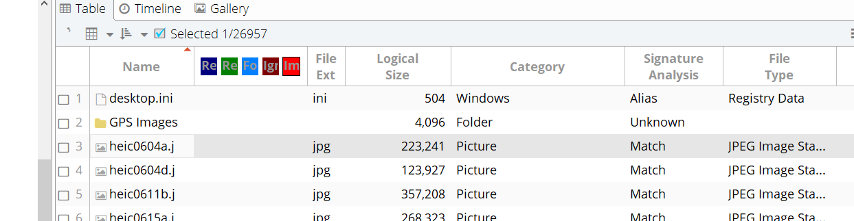
Note that a on performing a signature analysis EnCase will do the following:
- Determine the File Type by checking the file signature bytes
- Determine the category, based on the file type. For example files of type JPEG, GIF and other image formats with be categorized as “Picture”. Files of type Word Document and Adobe PDF will be classified as “Document”
- Check whether the file extension matches the signature, and set the Signature Analysis field to Match, Alias or Unknown.

Task 4: Investigate the use of Set Include
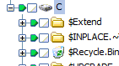
The Set Include icon is the green shape shown in the image on the right. When a file or folder is selected using the Set Include function, the contents of that file or folder will be displayed in the Table Pane. If the Set Include function is not used, then only the contents of the current folder will be shown in the Table Pane. The Set Include function only affects the viewing of the items, and does not select them for processing.
This is useful for viewing images, for example. In the entries, browse to \users\laquita\Pictures\P1. Select Gallery View. This will show all the images in the currently selected folder in the gallery view.
Now select the Set Include function at the "laquita" folder level and again go to Gallery View. This will show all the images in the laquita folder and sub folders. Try again at the Root level of the Drive. This will perform “Set Include” on every file on the drive. What happens to the Gallery View? Why do you think this could be useful in Forensic examinations?

Task 4b: Investigate the use of Blue Checking
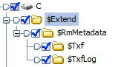
Blue Checking an Item selects this item for further processing, such as performing a search or calculating a hash value. It does not affect the viewing panes, it only affects which items will be processed. The Blue Check icon is shown on the right.
Note that there is also a single box which shows how many items have been “Blue Checked”. This is useful for checking before the operation that it will be performed on the correct number of items. It can also be used to Check or Uncheck all items at once.
Use Blue Checking to select and export all the images in the folder “\users\laquita\pictures\GPS Images”

Task 5: Use Signature Analysis to find Evidence
Select the Filter options. Choose Default, Items, and Find Items by Signature. 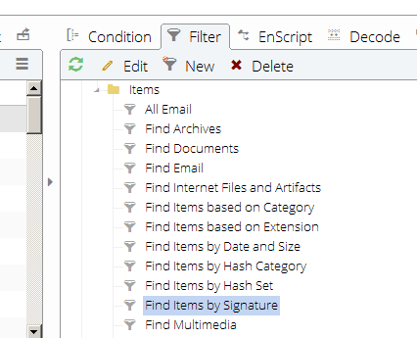
Select Entries and Current Device, and give your search a sensible name such as "Find Alias files"
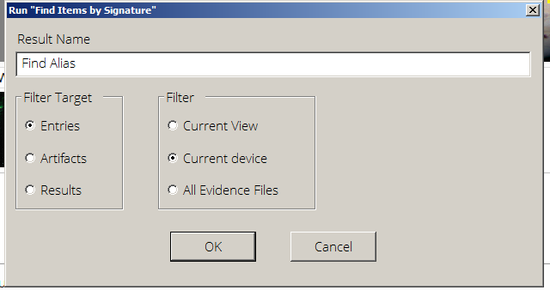
Select "Renamed Extension" only. These are "Alias" files.
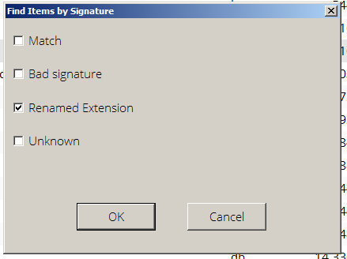
There are hundreds of files. Sort them by the file extension, and find a file with the extension .brd. Encase does not recognize this extension. View the file contents in text view with EnCase. This looks like an XML file, so EnCase flags this as XML with an Alias extension. Export the logical file to your D:\ drive.
Your task is to find out what application was used to create this file. Download the software required (you may need to use a trial version), and view the file using the correct application. If you cannot find which application was used, then try the one provided in the Student Files.zip file.
Can you find any evidence that John Smith (another user on Laquita’s computer) was involved in bomb-making?

Task 6: Find images
Some users rename image files because they become "hidden" from ordinary users - but not from Forensic Examiners!
There are five images on the disk with a banner "Evidence" in the image. You need to find these. In real life, these would have been illegal images, but you are only looking for "faked" evidence and the banner is what identifies these files as "evidence".
There are two ways to find these images - one way is to use the "Set Include" to include all files on the disk, then use the "Gallery View" to view the images. The other way is to select files by file Category. Since EnCase has already done a signature analysis, each file will have been categorized according to the contents, regardless of file name or extension. All images which begin with a file signature in the contents of the file which matches the signature for an image format such as JPEG, GIF or PNG will be categorized as "Pictures".
In the bottom right hand corner of EnCase, choose Filter, and "Find items based on Category", choose "Entries" and "Current Device", Then choose the category "Pictures". This will find all pictures on the current device. EnCase will open a tab call results, and show the results of the filter process. You should find 419 images. You can then use gallery view to view the pictures and visually find the ones with the Yellow Banner “Evidence” on them.
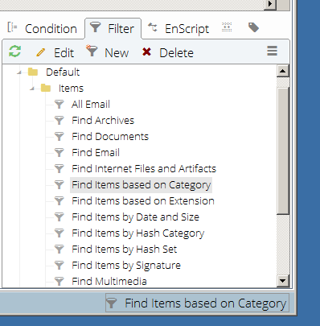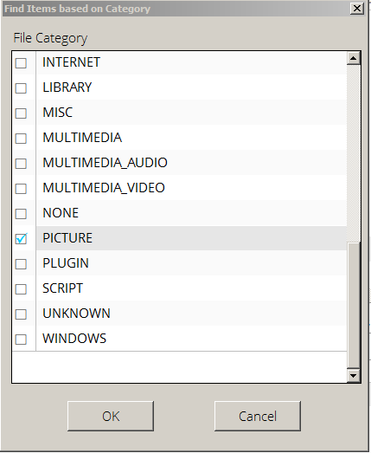
Note that the five images found are all different image formats. Complete the table below showing the file type and signature by looking at the contents of the file (in hex view) and the File Type defined by EnCase Signature Analysis.

Image Formats
Format | Signature Hex | Signature ASCII | extension
Tagged Image File Format
Joint Photographic Experts Group
Bitmap
Graphic Interchange Format
Portable Network Graphics

In both cases – the Gallery View and the “Find Items based on Category”, you have to visually search for relevant images, looking at each image to find the "evidence" banner. This is time consuming, and clearly not appropriate for very large sets of images. We will later look at some ways of automating image processing.

Task 7: Use Metadata to find where photographs have been taken
Images stored in jpg and other image specific formats used by digital cameras will store a large amount of application metadata in the contents of the image file. This data is called EXtended Image Format or EXIF data.
EXIF Data stores a number of details of which can be recorded by the camera (or phone). These include
- Camera Make and Model
- Date and Time taken
- GPS co-ordinates and Altitude
- Aperture, Exposure and Flash
Many of these items may be important for forensic investigators.
Find the following files on the evidence disk and extract them - you can use the results of your Filter Process from Task 6, and sort the files by name:
- P1.jpg to P7.jpg
Irfanview is one of the easiest ways to view the Image Metadata. Run the Irfanview application in your VM, and drag the images onto the Irfanview window to open them, or use File Open. In Irfanview, click on the Image tab on the top row, then choose Information. View the basic details, then click on the EXIF info button. Note that you can copy these to your clipboard.
To view a map of the location, click on the “Show in Google Maps” button. This will open a web browser with the location pinpointed in Google Maps.
Note that you can also get the location by viewing the GPS Latitude and Longitude details, but this is more difficult to pinpoint, and you need to take care because some systems use Degrees and Decimals, while others use Degrees, Minutes and Seconds.

Other ways of viewing EXIF Data:
Use the following methods of extracting EXIF Data:
- File Properties in Windows Explorer
- www.exifdata.com
- Jeffries Exif viewer
Can you get this information from EnCase? If so, how?
Task 8: Remove Metadata from Word Documents
Create and save a Word Document using the SHU Desktop. Right click on the document and view Properties and details. List all the items which could possibly identify you, or link the document to SHU. Do you always want this information to be sent with the file? What other Metadata may you want to clear when, for example, you send an application for a job?
To remove this metadata, right click on the document, select Properties then Details. Click on the item at the bottom of the window indicating “Remove Properties and Personal Information”. This can also be done for other MS Office documents such as PowerPoint.

Questions
What is the difference between Set Include and Blue Check? Windows Explorer does not have such a facility. Why do you think EnCase needed it?
How can a file end up with a date modified earlier than the date created?
Find files with "Unknown" signatures. What do you think these files are?

Extension Work
View the Evidence in timeline mode. How might this help you find evidence? How could timeline analysis be used as evidence in a case?

